Majestic Oaks Golf Club
2024 Indoor Boot Hockey League
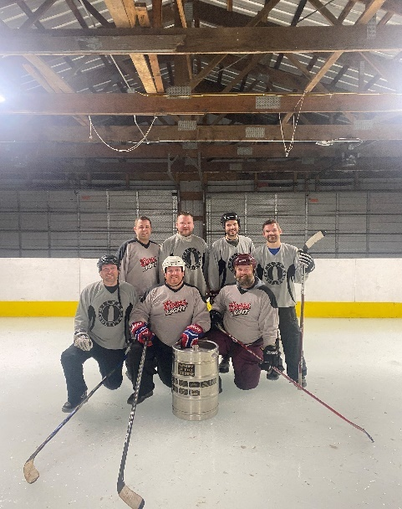
$400 League fee per team
Teams are made up of 5 - 10 players
League Information and Schedule
►All Entries with payment are due by Thursday, December 28, 2023
►8 week league with 2 weeks of Playoffs - Starts the week of January 2, 2024
►Games will be held in the indoor “Oaks Center” rink – Warming house provided.
►Games will be officiated
All other information can be found on our Boot Hockey website: www.mogcboothockey.com

League Night – Please check

______ Sunday B Division ____Tuesday B Division

__________ Wednesday Open Division ______Thirsty Thursday Open Division

Team Name:__________________________________________________
Captain’s Name:______________________Phone #___________________
Email:________________________________________________________

Player Player
1.______________________________________ 6.____________________________________

2.______________________________________ 7.____________________________________

3.______________________________________ 8.____________________________________

4.______________________________________ 9.____________________________________

5.______________________________________ 10.___________________________________
Any questions please contact Adam Erickson at Aerickson@arcisgolf.com
or 763-755-2142

