Majestic Oaks Golf Club
2017-2018 Indoor Boot Hockey League
Sign up sheet for Indoor Boot Hockey at Majestic Oaks
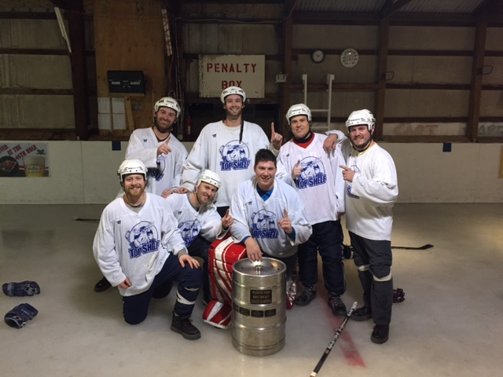
$300 League fee per team
Teams are made up of 5 - 10 players
League Information and Schedule
►All Entries with payment are due by Sunday, December 10, 2017
►8 week league with 2 weeks of Playoffs - Starts the week of December 17, 2017(weather permitting)
►Games will be held in the indoor “Oaks Center” rink – Warming house provided.
►Games will be officiated
►Co-Ed League is offered on Thursday Nights
All other information can be found on our Boot Hockey website: www.mogcboothockey.com
League Night – Please check
Majestic Oaks will determine A or B Division of teams

________Monday A Division ________Tuesday B Division

__________Wednesday A Division ___________Thursday Co-Ed

________Sunday B Division

Team Name:__________________________________________________
Captain’s Name:______________________Phone #___________________
Email:________________________________________________________

Player Player
1.______________________________________ 6.____________________________________

2.______________________________________ 7.____________________________________

3.______________________________________ 8.____________________________________

4.______________________________________ 9.____________________________________

5.______________________________________ 10.___________________________________
Any questions please contact Adam Erickson at Aerickson@arcisgolf.com
or 763-755-2142

